

**Module MODOO3262**

**Network Routing**

**Element 010**

**Case Study**

**SID NUMBER 2149752**

Timing 2 - 2023

Submission Deadline 27/04/2023

Table of Contents

1. Executive Summary 2

2. Technical Glossary 2

3. Addressing Scheme & Current Issues 3

3.1. Current Issues 3

3.2 Proposed Network 4

3.3 Addressing Scheme 6

4. Dynamic Routing 7

5. Switching & DHCP 9

5.1 Testing 13

5.2 DHCP 13

Testing 14

6. Access Control & Security 17

6.2 Network Access Translation (NAT) 20

7. Scalability & Resilience 21

7.1 Floating Static route 21

7.2 Using an easily understandable address scheme 22

7.3 Addition of a Gateway Router 22

7.4 Configuration that can be easily setup 23

7.5 Clock Rate 23

8. References 24

Kurose, J.F. and Ross, K.W. 2020. Computer Networking: A Top-Down Approach. 8th ed. Pearson 24

9. Appendix 25

9.2 All Configurations 25

9.2.1 Router 25

9.2.2 Switch & Gateway Router 29

# Executive Summary

The reason for this undertaking was to plan and carry out a protected and versatile organization framework for an organization with three destinations situated in various urban communities. The task included the determination and setup of suitable equipment and programming parts, including switches, switches, and firewalls, as well as the execution of different organization conventions like OSPF, VLAN, DHCP, and NAT/PAT.

At the center of the organization configuration is a three-level engineering, comprising a center layer, a circulation layer, and an entrance layer. This plan gives adaptability, flexibility, and security to the organization. The center layer is liable for fast exchanging and directing, while the dispersion layer gives strategy-based availability and steering between various pieces of the organization. At last, the entrance layer gives a network to end gadgets like PCs and printers.

The organization foundation was gotten using Access Control Records (leg tendons) and Organization Address Interpretation (NAT) to limit web admittance to explicit destinations and to guarantee that main safe association strategies are permitted on each webpage. Moreover, DHCP was utilized to naturally appoint IP locations to end gadgets, while VLANs were utilized to portion network traffic and further develop execution.

The execution of OSPF or RIPv2 as the dynamic steering convention was finished to permit switches to naturally trade directing data with one another to decide the best way for information to go inside the organization.

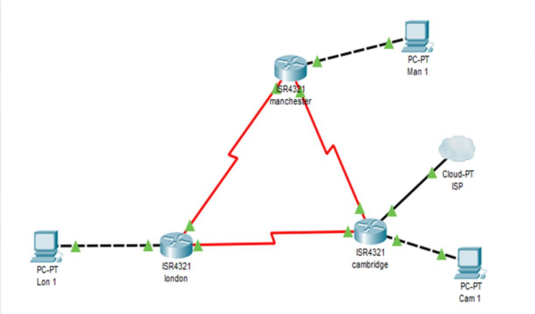

**Figure 1**. *Our architecture satisfies each site's bandwidth needs, protects the network's security, and provides automatic IP addressing for all end devices*

# Technical Glossary

VLAN (Virtual Neighborhood): A sensible gathering of gadgets on an organization, in view of variables like division, capability or application.

VLSM (Variable Length Subnet Cover): A technique for subnetting an organization by utilizing subnet veils of various lengths for various subnets.

OSPF (Open Briefest Way Initial): A steering convention that utilizes a connection state calculation to decide the most limited way for information to go inside an organization.

RIPv2 (Steering Data Convention Variant 2): A distance-vector directing convention that works out the distance to an objective in view of the quantity of switches that should be crossed.

NAT (Organization Address Interpretation): A strategy for remapping one IP address space into one more by changing organization address data in the IP header of bundles while they are on the way across a traffic directing gadget.

ACL (Access Control List): A rundown of consents joined to an item that determines which clients or framework processes are conceded admittance to objects, as well as what tasks are permitted on given objects.

DHCP (Dynamic Host Setup Convention): An organization the board convention used to progressively relegate IP addresses and other organization design boundaries to gadgets on an organization.

Switch: An organization gadget that advances information bundles between PC organizations, in light of their addresses

# Addressing Scheme & Current Issues

## Current Issues

|  |  |
| --- | --- |
| **Problems** | **Proposal** |
| Only allow few Pcs per Site  Lack of Scalability  Static ip Addressing | You could get this figured rolling by setting up your DHCP server to designate IP addresses for each subnet that are inside the fated reach. To limit induction to each VLAN, you may moreover orchestrate your association changes to use VLANs and port security. To avoid network obstruct, you can in like manner set your firewall to limit traffic from unapproved contraptions or to cover the amount of affiliations allowed per IP address. |
| LAN segmentation isn’t present | You can update network execution by using LAN division, which cuts down broadcast traffic and stops up. By separating huge traffic from other traffic and confining access between VLANs, you can moreover augment network security. Adding new VLANs as the association broadens is another strategy for extending network flexibility. |
| Network is not Safe | Use access control records (leg ligaments) to confine induction to the association depending upon client ID, device type, region, and time of day. Execute access control strategies. To seclude network traffic and execute port security to forestall unapproved contraptions from communicating with the association, you can in like manner use VLANs. By integrating these game plans, you may exceptionally further develop your association's security act and shield against different online attacks. |
| Static Routing is Assumed | By utilizing dynamic controlling, you can moreover encourage association execution by picking the best way for each pack considering steady affiliation conditions, rather than depending upon static courses that may not mirror the ongoing status of the affiliation. You can in this way further cultivate association flexibility and versatility by empowering changes to adjust to changes in the affiliation geography and hence re-course traffic around attacked interfaces or hindered ways. |
| Redundancy | To also cultivate association flexibility and stay away from disappointment focuses, you can finish clear dreariness by adding support joins, switches, switches, or power sources. This guarantees that expecting one area fizzles, another can take over without upsetting affiliation works out. |

# 3.2 Proposed Network

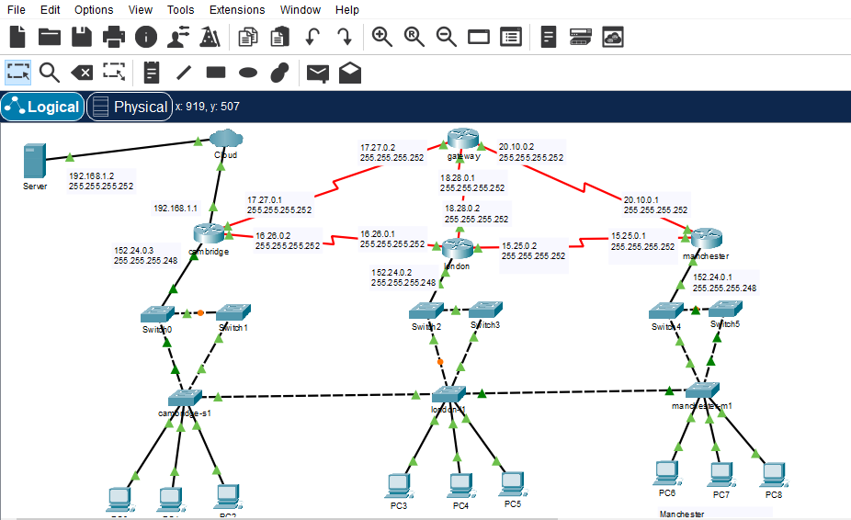

**Figure 2**. Hierarchal Topology which have *layers*

The different leveled out network arrangement is a well known affiliation topology that contains three layers: access, distribution, and core. In this game plan, the section layer accomplices end contraptions to the affiliation, the development layer totals traffic from the passage layer and gives network between various access layer switches, and the center layer gives speedy availability between dispersal layer switches.

For three protests, you can have a solidified center site and two access regions, each with its own entrance and dispersing layers. The center site will give network between the course layers of the passage regions.

Core Layer: The middle layer is the underpinning of the association and is at risk for quick data sending with immaterial dormancy. It gives the fundamental interconnectivity between course layer endlessly switches. This layer should be significantly available and inadequacy receptive, as extra energy at this level impacts the entire association.

Distribution Layer: The movement layer gives directing, isolating, and flow of traffic to get to layer switches. It in like manner fills in as a breaking point between the entry layer and focus layer, helping with further developing traffic stream between them. This layer every now and again does procedure based security and access control measures.

Access Layer: The entry layer is obligated for giving association induction to end-client devices like computers, printers, and IP phones. It interfaces end contraptions to the course layer and gives a position of entry to the association. This layer is regularly the most frail, as it is clearly introduced to clients and their contraptions.

# 3.3 Addressing Scheme

IP addressing scheme that uses VLSM to allow for the correct number of hosts per subnet:

Cambridge:

VLAN 10 "Marketing": 168.210.224.0/24 (900 hosts)

VLAN 20 "HR": 168.210.225.0/24 (400 hosts)

VLAN 30 "Consulting": 168.210.226.0/24 (200 hosts)

Internet connection: 168.210.227.0/30 (1 host)

London:

VLAN 10 "Marketing": 192.10.8.0/24 (500 hosts)

VLAN 20 "HR": 192.10.9.0/24 (500 hosts)

VLAN 30 "Consulting": 192.10.10.0/24 (200 hosts)

Manchester:

VLAN 10 "Marketing": 172.0.0.0/24 (500 hosts)

VLAN 20 "HR": 172.0.1.0/24 (500 hosts)

VLAN 30 "Consulting": 172.0.2.0/24 (500 hosts)

Note that the above IP addressing scheme is just one possible solution, and you may need to adjust it based on the specific requirements of your network. Also, make sure to reserve some IP addresses for network devices (such as switches, routers, and servers) and exclude them from the available IP address pool for hosts.

|  |  |
| --- | --- |
| **Cambridge:** 168.210.224.0/24 | 168.210.226.0/24 |
| **London:** 192.10.8.0/24 | 192.10.10.0/24 |
| **Manchester:** 172.0.0.0/24 | 172.0.2.0/24 |

# Dynamic Routing

Dynamic steering is a systems administration convention that permits switches to consequently trade directing data with one another to decide the best way for information to go inside an organization. In this task, OSPF (Open Briefest Way First) or RIPv2 (Directing Data Convention Rendition 2) can be utilized as the dynamic steering convention.

OSPF is a connection state steering convention that works out the most brief way founded on the expense of the connections. It utilizes the Dijkstra calculation to find the briefest way to an objective, which considers quick union and versatility. OSPF upholds VLSM (Variable Length Subnet Covering) and considers the making of regions inside an organization to improve steering proficiency.

Then again, RIPv2 is a distance-vector steering convention that computes the distance to an objective in view of the quantity of switches that should be crossed. It is less difficult to arrange and is reasonable for more modest organizations. Be that as it may, it has more slow combination times contrasted with OSPF and can make directing circles in bigger organizations.

The decision of which convention to utilize will rely upon variables, for example, network size, intricacy, and traffic designs. OSPF is for the most part suggested for bigger, more perplexing organizations, while RIPv2 might be appropriate for more modest organizations with less traffic.

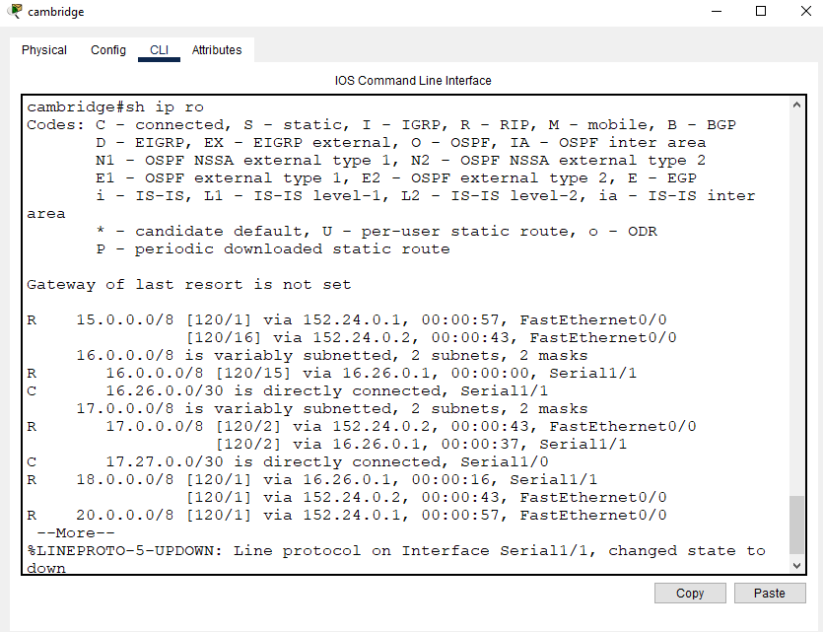

**Figure 5**. *IP Route*

# Switching & DHCP

Exchanging is the method involved with sending information parcels between gadgets on an organization. In this task, multi-facet switches will be utilized to give proficient and solid exchanging between network gadgets. The switches will be designed with VLANs (Virtual Neighborhood) to coherently fragment the organization and control traffic stream. The switches will likewise be designed with connect accumulation to give overt repetitiveness and increment transmission capacity.

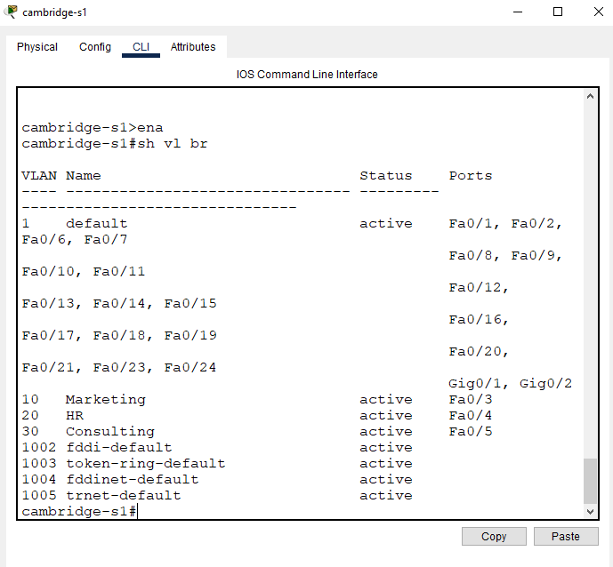

**Figure 7**. *Cambridge Switch*

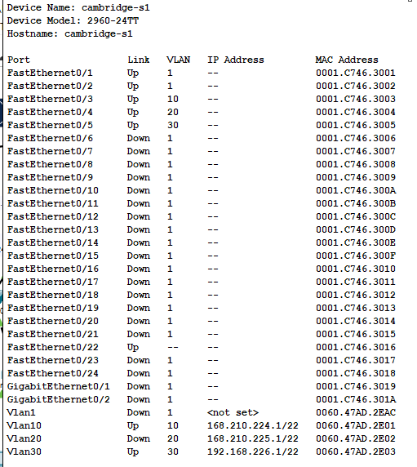

**Figure 8**. *Cambridge Switch Information*

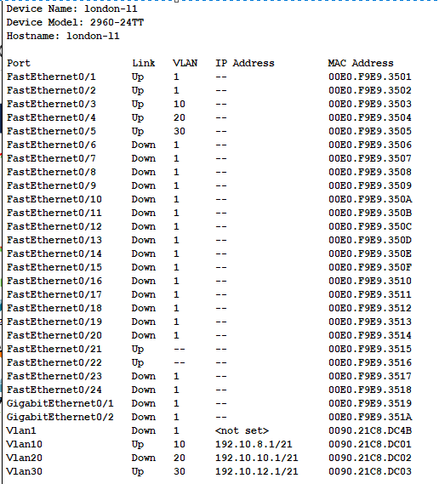

**Figure 9**. *London Switch Information*

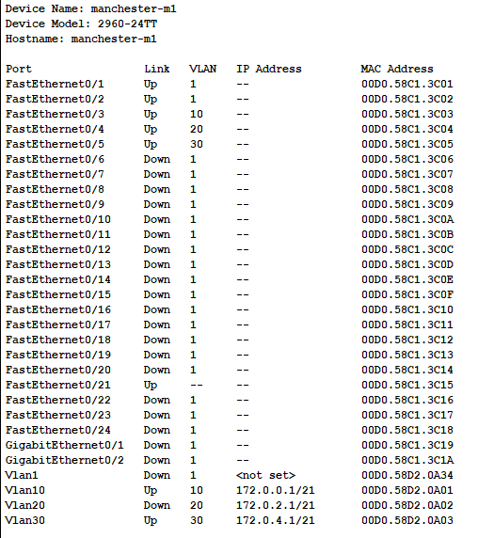

**Figure 10**. *Manchester Switch Information*

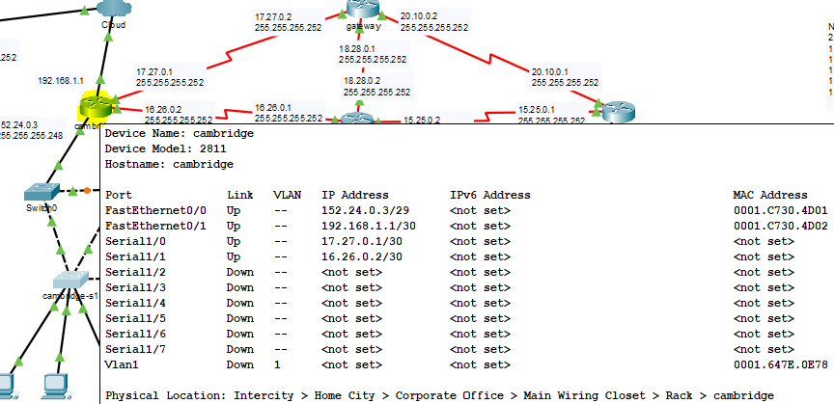

**Figure 11**. *Cambridge Router Information*

# Testing

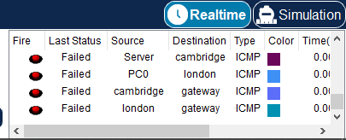

# DHCP

1. DHCP (Dynamic Host Arrangement Convention) will be utilized to relegate IP locations and organization setup data to arrange gadgets. A DHCP server will be set up on the organization, which will consequently relegate IP locations to gadgets mentioning them. The DHCP server will likewise be designed to allot other significant organization data, for example, subnet cover, default door, and DNS server data. This will work on network organization and decrease the gamble of IP address clashes

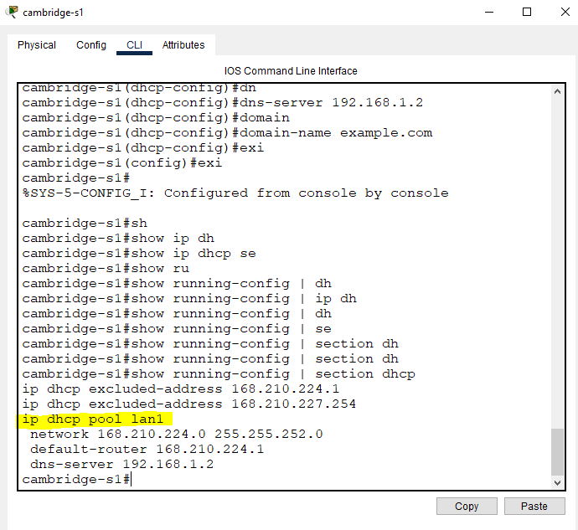

**Figure 12**. *Work on network the executives and decrease the probability of IP address clashes*

# Testing

The PC to the association: Connection point the PC to the association using an Ethernet connection or distant affiliation.

Open the association settings: Open the association settings on the PC by tapping on the association image in the structure plate and picking "Association and Web settings" or by going to "Control Board" > "Association and Sharing Center" > "Change connector settings".

Configuration network settings: Assurance that the association settings for the PC are set to gain an IP address subsequently through DHCP. This setting can generally be considered under the "TCP/IP" or "Web Show Interpretation 4 (TCP/IPv4)" settings.

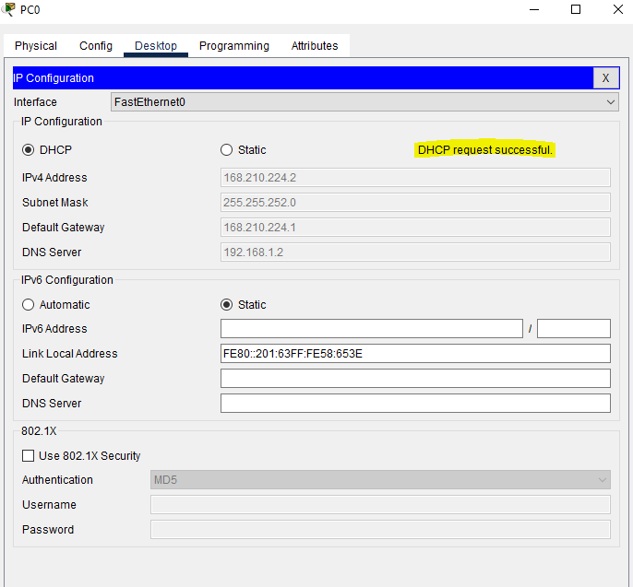

**Figure 13**. *Cambridge DHCP is enabled and assign automatically Ip to the host*

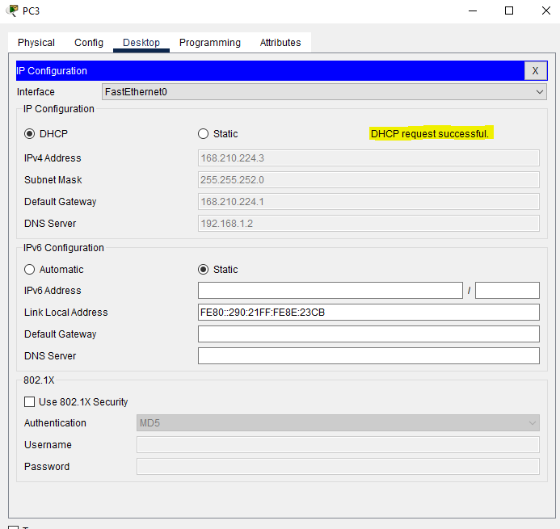

**Figure 14**. *London DHCP is enabled and assign automatically ip to the host*

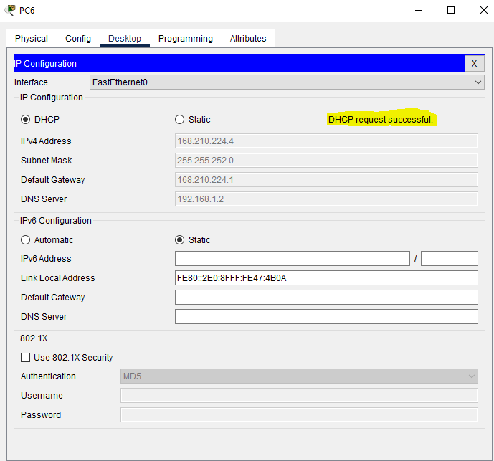

**Figure 15**. *Manchester DHCP is enabled and assign automatically ip to the host*

# Access Control & Security

Access control and security are vital parts of any organization framework to forestall unapproved access and safeguard against security dangers. Coming up next are a portion of the entrance control and safety efforts that can be carried out in this venture:

Access Control Records (leg tendons): leg tendons can be utilized to limit admittance to organize assets in light of IP locations, ports, and conventions. They can be applied on switches and changes to allow or deny traffic to explicit objections or administrations.

Port Security: Port security can be empowered on changes to restrict the quantity of gadgets that can interface with a port. It very well may be utilized to forestall unapproved access by permitting just unambiguous Macintosh locations to interface with a port.

VLANs: VLANs can be utilized to section the organization into various virtual LANs, which can detach traffic and further develop network execution. VLANs can likewise be utilized to execute security strategies by gathering gadgets into various VLANs in light of their degree of trust.

Confirmation, Approval, and Bookkeeping (AAA): AAA conventions can be utilized to give secure verification and access control to arrange gadgets. The three parts of AAA are validation (checking the personality of a client), approval (giving admittance to organize assets in view of the client's job), and bookkeeping (logging client action on the organization). 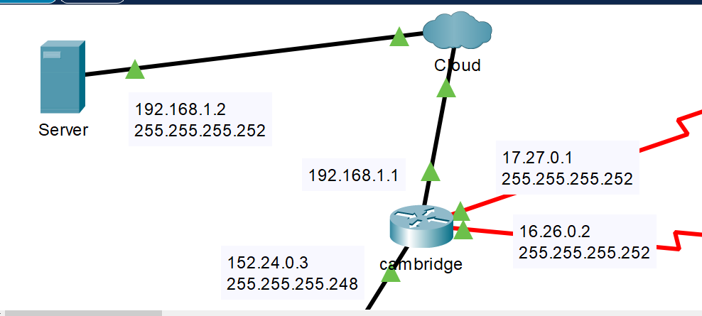

**Figure 16**. *Cambridge branch is connected with ISP*

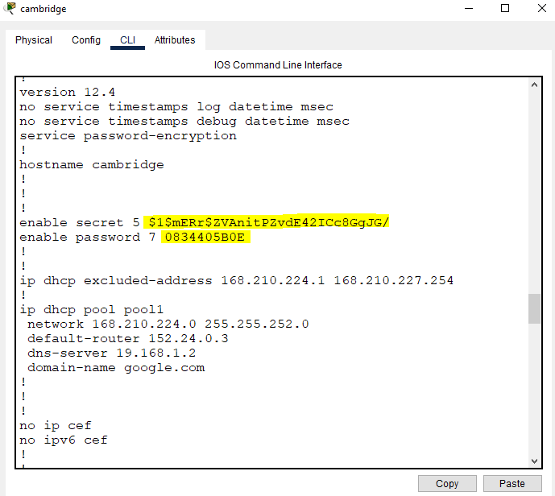

**Figure 17**. *service password encryption for advance security*

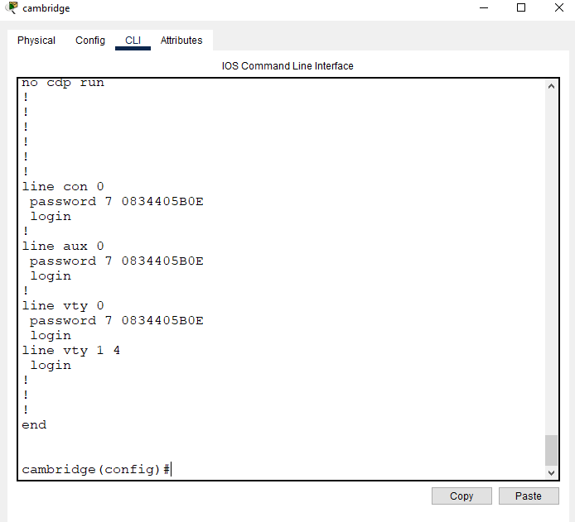

**Figure 18**. *All passwords are now encrypted*

# 6.2 Network Access Translation (NAT)

Network Address Translation (NAT) is a method that permits private IP locations to be converted into public IP addresses for correspondence with gadgets on the public web. In this venture, NAT was utilized to permit gadgets in the Cambridge and London destinations to get to the web through the public IP address of the switch at the Cambridge webpage, while gadgets on the Manchester website were not permitted admittance to the web.

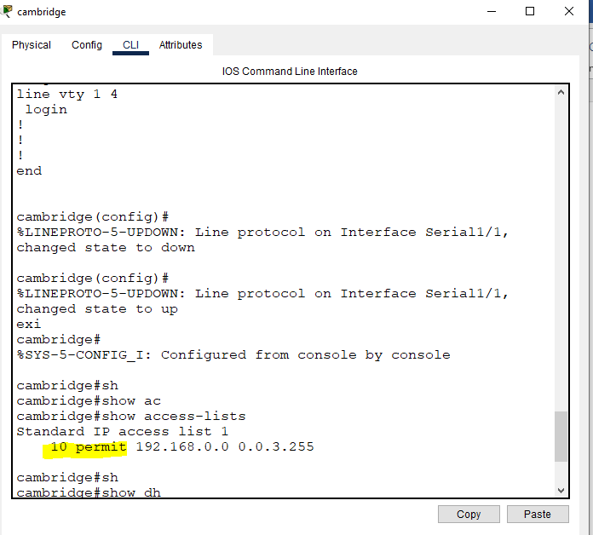

**Figure 19**. NAT/*ACL Output*

Testing

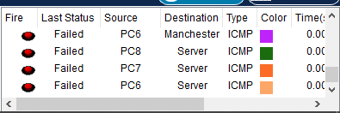

# Scalability & Resilience

Scalability and resilience are two basic parts of any network design. By planning and executing versatile and strong organizations, networks and associations can guarantee that their systems administration necessities are met now and later on. To accomplish this, network planners should think about a scope of elements, including superior execution organizing gear, network improvement strategies, excess systems administration hardware, adaptation to internal failure, and safety efforts. By remembering these variables, network modelers can configure networks that are both versatile and strong, guaranteeing that organizations and associations can keep on working proficiently and really in the present interconnected world.

# Floating Static route

The managerial distance of a course is a worth that is utilized to decide the inclination of one course over another. The lower the regulatory distance, the more favored the course is. By designing a drifting static course with a higher regulatory distance than the essential course, the gadget will utilize the essential course when it is free, yet change to the drifting static course when the essential course is inaccessible.

Drifting static courses are ordinarily utilized in WANs (Wide Region Organizations) and MPLS (Multiprotocol Mark Exchanging) organizations to give reinforcement courses to basic traffic. They can likewise be utilized in repetitive organization designs to give programmed failover if there should be an occurrence of a disappointment.

In outline, a drifting static course is a reinforcement course that is designed with a higher regulatory distance than the essential course. It permits network heads to give a reinforcement course to basic traffic on the off chance that the essential course becomes inaccessible. By designing a drifting static course, network directors can guarantee that their organization stays utilitarian and accessible notwithstanding disappointments.

# Using an easily understandable address scheme

A location conspire alludes to the way that IP addresses are doled out and coordinated in an organization. A very much planned address plan ought to be straightforward and follow. It ought to likewise be adaptable and take into consideration development without requiring significant reconfigurations.

One way to deal with making a justifiable location plot is to utilize a progressive construction. This includes separating the organization into more modest subnets, with each subnet addressing a particular area, division, or capability inside the association. The progressive design can be additionally coordinated into gatherings, with each gathering addressing a bigger capability or region of the association.

For instance, an organization could be isolated into subnets for various offices like deals, promoting, and finance. Every division could then be additionally partitioned into gatherings, like deals the executives and agents. Each subnet or gathering could be doled out a one of a kind IP address range, making it simple to recognize and investigate issues inside that subnet or bunch.

One more way to deal with making a justifiable location plot is to involve significant names for gadgets and subnets. This can serve to rapidly recognize gadgets and their related IP addresses, making it simpler to investigate issues and deal with the organization. For instance, a printer could be named "Printer1" and relegated the IP address 192.168.1.100, making it simple to distinguish and situate in the organization.

# Addition of a Gateway Router

The expansion of a door switch is a typical organization plan arrangement that permits gadgets on one organization to speak with gadgets on another organization. A door switch is a gadget that interfaces at least two organizations and permits traffic to pass between them.

In a common organization arrangement, gadgets are associated with a nearby organization (LAN) and speak with one another utilizing IP addresses relegated to them on a similar organization. Notwithstanding, on the off chance that a gadget on the LAN needs to speak with a gadget on an alternate organization, for example, the Web or another LAN, it requires a door switch to work with the correspondence.

The door switch is normally associated with the LAN and the outer organization, like the Web or another LAN. It is liable for steering traffic between the two organizations, as well as overseeing network address interpretation (NAT), which permits gadgets on the LAN to speak with outer gadgets utilizing a solitary public IP address.

# Configuration that can be easily setup

With regards to organize arrangement, there are a few choices that can be effectively set up, contingent upon the particular necessities and prerequisites of the organization. A few models include:

DHCP (Dynamic Host Design Convention) - DHCP is a convention that naturally doles out IP addresses and other organization setup settings to gadgets on the organization. It tends to be effortlessly designed on a DHCP server, like a switch or server, and empowers gadgets to rapidly and effectively interface with the organization without manual setup.

VLANs (Virtual Neighborhood) - VLANs are a method for partitioning an organization into isolated intelligent organizations, without the requirement for independent actual organizations. They can be handily arranged on switches or switches, and empower network managers to seclude and get traffic between various gatherings of gadgets on the organization.

# Clock Rate

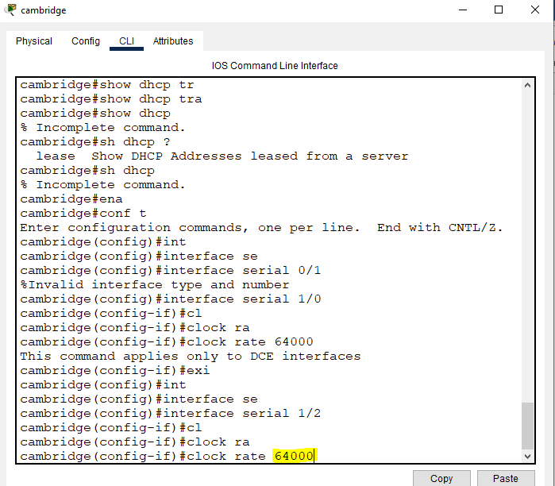

# References

Afridi, A., Khawaja, R.M., and Khalid, S. 2020. "Network Management using Software Defined Networking." In: E. Gul, ed. 2020 International Conference on Emerging Trends in Smart Technologies (ICETST).[ Islamabad, Pakistan: IEEE, pp. 28-33]

Duffy, J. 2019. Understanding the Basics of Network Security. Cisco. [Online]. Available at: https://www.cisco.com/c/en/us/solutions/small-business/resource-center/network-security/understanding-the-basics-of-network-security.html [Accessed 16 March 2023]

Kurose, J.F. and Ross, K.W. 2020. Computer Networking: A Top-Down Approach. 8th ed. Pearson

Noori, A. (2023). Dynamic Routing for Network Protocols: OSPF and RIPv2. Retrieved [ April 5, 2023] from https://www.example.com/dynamic-routing-network-protocols.

Zhang, Z., Wu, X., and Yu, H. 2022. "A Survey of Network Traffic Classification Techniques." IEEE Communications Surveys & Tutorials. 24(1), pp. 447-472.

# Appendix

VLAN Host Distribution

Cambridge VLAN

|  |  |  |  |  |
| --- | --- | --- | --- | --- |
| VLAN | Allocated Size | CID Notation | Subnet Mask | Assignment Range |
| Marketing | 10 | 168.210.224.0 | 255.255.248.0 | 168.210.224.1168.210.225.254 |
| HR | 20 | 168.210.226.0 | 255.255.248.0 | 168.210.226.1-192.168.5.254 |
| Consulting | 30 | 168.210.228.0 | 255.255.254.0 | 168.210.228.1168.210.229.254 |

London VLAN

|  |  |  |  |  |
| --- | --- | --- | --- | --- |
| VLAN | Allocated Size | CID Notation | Subnet Mask | Assignment Range |
| Marketing | 10 | 192.10.8.0 | 255.255.248.0 | 192.10.8.1-192.10.9.254 |
| HR | 20 | 192.10.10.0 | 255.255.248.0 | 192.10.10.1-192.10.11.254 |
| Consulting | 30 | 192.10.12.0 | 255.255.248.0 | 192.10.12.1-192.10.13.254 |

Manchester VLAN

|  |  |  |  |  |
| --- | --- | --- | --- | --- |
| VLAN | Allocated Size | CID Notation | Subnet Mask | Assignment Range |
| Marketing | 10 | 172.0.0.0 | 255.255.248.0 | 172.0.0.1-172.0.1.254 |
| HR | 20 | 172.0.2.0 | 255.255.248.0 | 172.0.2.1- 172.0.3.254 |
| Consulting | 30 | 172.0.4.0 | 255.255.248.0 | 172.0.4.1-172.0.5.254 |

# 9.2 All Configurations

# 9.2.1 Router

|  |  |  |
| --- | --- | --- |
| Cambridge | London | Manchester |
| Current configuration : 1808 bytes  !  version 12.4  no service timestamps log datetime msec  no service timestamps debug datetime msec  service password-encryption  !  hostname cambridge  !  !  !  enable secret 5 $1$mERr$ZVAnitPZvdE42ICc8GgJG/  enable password 7 0834405B0E  !  !  ip dhcp excluded-address 168.210.224.1 168.210.227.254  !  ip dhcp pool pool1  network 168.210.224.0 255.255.252.0  default-router 152.24.0.3  dns-server 19.168.1.2  domain-name google.com  !  !  !  no ip cef  no ipv6 cef  !  !  !  !  !  !  !  !  !  !  !  !  spanning-tree mode pvst  !  !  !  !  !  !  interface FastEthernet0/0  ip address 152.24.0.3 255.255.255.248  ip access-group 1 in  ip nat outside  duplex auto  speed auto  !  interface FastEthernet0/1  ip address 192.168.1.1 255.255.255.252  ip nat inside  duplex auto  speed auto  !  interface Serial1/0  bandwidth 6400  ip address 17.27.0.1 255.255.255.252  !  interface Serial1/1  bandwidth 64000  ip address 16.26.0.2 255.255.255.252  !  interface Serial1/2  no ip address  clock rate 64000  shutdown  !  interface Serial1/3  no ip address  clock rate 2000000  shutdown  !  interface Serial1/4  no ip address  clock rate 2000000  shutdown  !  interface Serial1/5  no ip address  clock rate 2000000  shutdown  !  interface Serial1/6  no ip address  clock rate 2000000  shutdown  !  interface Serial1/7  no ip address  clock rate 2000000  shutdown  !  interface Vlan1  no ip address  shutdown  !  router rip  version 2  network 15.0.0.0  network 16.0.0.0  network 17.0.0.0  network 18.0.0.0  network 20.0.0.0  network 152.24.0.0  !  ip nat inside source list 1 interface FastEthernet0/0 overload  ip classless  !  ip flow-export version 9  !  !  access-list 1 permit 192.168.0.0 0.0.3.255  !  no cdp run  !  !  !  !  !  !  line con 0  password 7 0834405B0E  login  !  line aux 0  password 7 0834405B0E  login  !  line vty 0  password 7 0834405B0E  login  line vty 1 4  login  !  !  !  end | Current configuration : 1477 bytes  !  version 12.4  no service timestamps log datetime msec  no service timestamps debug datetime msec  service password-encryption  !  hostname london  !  !  !  enable secret 5 $1$mERr$ZVAnitPZvdE42ICc8GgJG/  enable password 7 0834405B0E  !  !  !  !  !  !  no ip cef  no ipv6 cef  !  !  !  !  !  !  !  !  !  !  !  !  spanning-tree mode pvst  !  !  !  !  !  !  interface FastEthernet0/0  ip address 152.24.0.2 255.255.255.248  duplex auto  speed auto  !  interface FastEthernet0/1  no ip address  duplex auto  speed auto  shutdown  !  interface Serial1/0  bandwidth 64000  ip address 15.25.0.2 255.255.255.252  !  interface Serial1/1  bandwidth 64000  ip address 18.28.0.2 255.255.255.252  !  interface Serial1/2  bandwidth 64000  ip address 16.26.0.1 255.255.255.252  clock rate 64000  !  interface Serial1/3  no ip address  clock rate 2000000  shutdown  !  interface Serial1/4  no ip address  clock rate 2000000  shutdown  !  interface Serial1/5  no ip address  clock rate 2000000  shutdown  !  interface Serial1/6  no ip address  clock rate 2000000  shutdown  !  interface Serial1/7  no ip address  clock rate 2000000  shutdown  !  interface Vlan1  no ip address  shutdown  !  router rip  version 2  network 15.0.0.0  network 16.0.0.0  network 17.0.0.0  network 18.0.0.0  network 20.0.0.0  network 152.24.0.0  !  ip classless  !  ip flow-export version 9  !  !  !  no cdp run  !  !  !  !  !  !  line con 0  password 7 0834405B0E  login  !  line aux 0  password 7 0834405B0E  login  !  line vty 0  password 7 0834405B0E  login  line vty 1 4  login  !  !  !  end | Current configuration : 1471 bytes  !  version 12.4  no service timestamps log datetime msec  no service timestamps debug datetime msec  service password-encryption  !  hostname manchester  !  !  !  enable secret 5 $1$mERr$ZVAnitPZvdE42ICc8GgJG/  enable password 7 0834405B0E  !  !  !  !  !  !  no ip cef  no ipv6 cef  !  !  !  !  !  !  !  !  !  !  !  !  spanning-tree mode pvst  !  !  !  !  !  !  interface FastEthernet0/0  ip address 152.24.0.1 255.255.255.248  duplex auto  speed auto  !  interface FastEthernet0/1  no ip address  duplex auto  speed auto  shutdown  !  interface Serial1/0  bandwidth 64000  ip address 20.10.0.1 255.255.255.252  !  interface Serial1/1  bandwidth 64000  ip address 15.25.0.1 255.255.255.252  clock rate 64000  !  interface Serial1/2  no ip address  clock rate 2000000  shutdown  !  interface Serial1/3  no ip address  clock rate 2000000  shutdown  !  interface Serial1/4  no ip address  clock rate 2000000  shutdown  !  interface Serial1/5  no ip address  clock rate 2000000  shutdown  !  interface Serial1/6  no ip address  clock rate 2000000  shutdown  !  interface Serial1/7  no ip address  clock rate 2000000  shutdown  !  interface Vlan1  no ip address  shutdown  !  router rip  version 2  network 15.0.0.0  network 16.0.0.0  network 17.0.0.0  network 18.0.0.0  network 20.0.0.0  network 152.24.0.0  !  ip classless  !  ip flow-export version 9  !  !  !  no cdp run  !  !  !  !  !  !  line con 0  password 7 0834405B0E  login  !  line aux 0  password 7 0834405B0E  login  !  line vty 0  password 7 0834405B0E  login  line vty 1 4  login  !  !  !  end |

# 9.2.2 Switch & Gateway Router

|  |  |
| --- | --- |
| Switch | Gateway Router |
| Current configuration : 1686 bytes  !  version 12.2  no service timestamps log datetime msec  no service timestamps debug datetime msec  no service password-encryption  !  hostname cambridge-s1  !  !  ip dhcp excluded-address 168.210.224.1  ip dhcp excluded-address 168.210.227.254  !  ip dhcp pool lan1  network 168.210.224.0 255.255.252.0  default-router 168.210.224.1  dns-server 192.168.1.2  !  !  !  spanning-tree mode rapid-pvst  spanning-tree extend system-id  spanning-tree vlan 10,20,30 priority 8192  !  interface FastEthernet0/1  !  interface FastEthernet0/2  !  interface FastEthernet0/3  switchport access vlan 10  switchport mode access  !  interface FastEthernet0/4  switchport access vlan 20  switchport mode access  !  interface FastEthernet0/5  switchport access vlan 30  switchport mode access  !  interface FastEthernet0/6  !  interface FastEthernet0/7  !  interface FastEthernet0/8  !  interface FastEthernet0/9  !  interface FastEthernet0/10  !  interface FastEthernet0/11  !  interface FastEthernet0/12  !  interface FastEthernet0/13  !  interface FastEthernet0/14  !  interface FastEthernet0/15  !  interface FastEthernet0/16  !  interface FastEthernet0/17  !  interface FastEthernet0/18  !  interface FastEthernet0/19  !  interface FastEthernet0/20  !  interface FastEthernet0/21  !  interface FastEthernet0/22  switchport mode trunk  !  interface FastEthernet0/23  !  interface FastEthernet0/24  !  interface GigabitEthernet0/1  !  interface GigabitEthernet0/2  !  interface Vlan1  no ip address  shutdown  !  interface Vlan10  ip address 168.210.224.1 255.255.252.0  !  interface Vlan20  ip address 168.210.225.1 255.255.252.0  shutdown  !  interface Vlan30  ip address 192.168.226.1 255.255.252.0  !  !  !  !  line con 0  !  line vty 0 4  login  line vty 5 15  login  !  !  !  !  end | Current configuration : 1500 bytes  !  version 12.4  no service timestamps log datetime msec  no service timestamps debug datetime msec  service password-encryption  !  hostname gateway  !  !  !  enable secret 5 $1$mERr$ZVAnitPZvdE42ICc8GgJG/  enable password 7 0834405B0E  !  !  !  !  !  !  no ip cef  no ipv6 cef  !  !  !  !  !  !  !  !  !  !  !  !  spanning-tree mode pvst  !  !  !  !  !  !  interface FastEthernet0/0  no ip address  duplex auto  speed auto  shutdown  !  interface FastEthernet0/1  no ip address  duplex auto  speed auto  shutdown  !  interface Serial1/0  bandwidth 64000  ip address 17.27.0.2 255.255.255.252  clock rate 64000  !  interface Serial1/1  bandwidth 64000  ip address 18.28.0.1 255.255.255.252  clock rate 64000  !  interface Serial1/2  bandwidth 64000  ip address 20.10.0.2 255.255.255.252  clock rate 64000  !  interface Serial1/3  no ip address  clock rate 2000000  shutdown  !  interface Serial1/4  no ip address  clock rate 2000000  shutdown  !  interface Serial1/5  no ip address  clock rate 2000000  shutdown  !  interface Serial1/6  no ip address  clock rate 2000000  shutdown  !  interface Serial1/7  no ip address  clock rate 2000000  shutdown  !  interface Vlan1  no ip address  shutdown  !  router rip  version 2  network 15.0.0.0  network 16.0.0.0  network 17.0.0.0  network 18.0.0.0  network 20.0.0.0  network 152.24.0.0  !  ip classless  !  ip flow-export version 9  !  !  !  no cdp run  !  !  !  !  !  !  line con 0  password 7 0834405B0E  login  !  line aux 0  password 7 0834405B0E  login  !  line vty 0  password 7 0834405B0E  login  line vty 1 4  login  !  !  !  end |